CO1: Understand and articulate the evolution of mobile communication systems, cellular architecture, spectrum utilization, and Interference management in wireless communication networks.

UNIT I – EVOLUTION OF MOBILE COMMUNICATION & CELLULAR CONCEPTS
Evolution of Mobile Communication: 1G: Analog voice (AMPS, NMT, TACS) – FDMA; 2G: Digital voice & SMS (GSM, IS-95 CDMA) – TDMA/CDMA; 3G: Mobile internet (UMTS, CDMA2000) – WCDMA/HSPA; 4G: Broadband data (LTE, LTE-Advanced) – OFDMA, MIMO; 5G: eMBB, URLLC, massive IoT – mmWave, beamforming, massive MIMO; 6G Vision: Terahertz spectrum, AI-native networks, holographic communication, tactile internet, ISAC. Cellular Concepts: Cell structure: hexagonal model, coverage, capacity planning; Cell splitting: sectoring, microcells, picocells, femtocells; Handoff: hard, soft, softer; Interference management: CIR, adjacent channel interference. Spectrum: Spectrum bands: sub-1 GHz, mid-band (1–6 GHz), mmWave (>24 GHz); ITU framework: ITU-R, WRC, BR functions.

ECA 56 -LIST OF EXPERIMENTS

Exp. No. | Experiment | Duration (Expt.  Conduct + Evaluation) | CO | BL | WK | Type of Expt.
1 | Simulation and Comparative Analysis of FDMA, TDMA and CDMA: Resource Allocation, User Capacity and Mobile-  Generation Context | 45+ 15 min | CO1 | L4 | WK3 | Simulation

Experiment Number: 1
Simulation and Comparative Analysis of FDMA, TDMA and CDMA: Resource Allocation, User Capacity and Mobile-Generation Context

Aim
To simulate and compare the basic resource-allocation methods used in FDMA, TDMA and CDMA, and examine how their assumed user capacity and interference behaviour differ.

Objectives
By the end of the experiment, students should be able to:
- Model how FDMA, TDMA and CDMA allocate communication resources among users.
- Estimate and compare user capacity under stated assumptions.
- Plot how estimated CDMA SIR changes as the number of simultaneous users increases.
- Relate the access methods to representative mobile generations and interpret the limits of the simplified model.

Requirements
  - Computer with MATLAB
  - No hardware is required

Theoretical Background

FDMA gives users separate frequency channels. TDMA gives users separate time slots. CDMA allows users to share a frequency band and time by using different spreading codes. This experiment uses a simplified analytical model to illustrate those differences. It assumes ideal FDMA and TDMA resource separation, and estimates CDMA SIR using:
where G is the processing gain and K is the number of simultaneous users. SIR in decibels is:
𝑆𝐼𝑅𝑑𝑏 = 10 log₁₀ 𝑆𝐼𝑅

The model assumes ideal separation for FDMA and TDMA, and equal received power for CDMA users. It does not model fading, power control, adjacent-channel leakage, guard intervals or standard-specific constraints.

Procedure

Parameter | Value used | Meaning
Total bandwidth | 1 MHz | Total available frequency bandwidth
FDMA channel width | 200 kHz | Bandwidth allocated to each FDMA user
TDMA slots | 8 | Slots available per frame
CDMA processing gain | 64 | Assumed spreading/processing gain
CDMA target SIR | 7 dB | Minimum assumed SIR for the capacity estimate

Students should record any values they change.

Algorithm:

- Clear the MATLAB workspace, Command Window and open figures.
- Enter the system parameters.
- Estimate the FDMA and TDMA user limits.
- Convert the CDMA target SIR from decibels to a linear value.
- Estimate the CDMA user limit.
- Calculate CDMA SIR for a range of simultaneous user counts.
- Display the capacity table and generate the plots.
- Compare the results with the assumptions and explain their limitations.

Procedure:

- Run the MATLAB program below.
- Record the assumed bandwidth, channel width, number of TDMA slots, CDMA processing gain and target SIR.
- Inspect the printed capacity table and the capacity and CDMA-SIR plots.
- Inspect the generation comparison table and the conceptual time-frequency resource diagrams.
- Change at least one parameter for each access method and rerun the program.
- Compare the new and baseline results; explain the impact of the changed assumptions.

Program 1 — Capacity estimate for FDMA, TDMA and CDMA
Objective 1: To estimate and compare the illustrative number of users supported by FDMA, TDMA and CDMA using the specified system parameters.

MATLAB program:

>> % Comparison of FDMA, TDMA and CDMA
% Simplified illustrative model; not a full cellular-network simulation. clear; clc; close all;
% Illustrative system parameters

totalBandwidthHz | = | 1e6; | % | Total bandwidth: 1 MHz
fdmaChannelHz | = | 200e3; | % | FDMA channel width: 200 kHz
tdmaSlots | = | 8; | % | Number of TDMA slots per frame
processingGain | = | 64; | % | CDMA processing gain
targetSIRdB | = | 7; | % | Minimum acceptable CDMA SIR

% Capacity estimates under the stated assumptions fdmaUsers = floor(totalBandwidthHz / fdmaChannelHz); tdmaUsers = tdmaSlots;

targetSIR = 10^(targetSIRdB / 10);
cdmaUsers = floor(1 + processingGain / targetSIR);

fprintf('Illustrative maximum supported users\n'); fprintf('FDMA: %d users\n', fdmaUsers); fprintf('TDMA: %d users\n', tdmaUsers);
fprintf('CDMA: %d users at a target SIR of %.1f dB\n\n', ... cdmaUsers, targetSIRdB);

% CDMA SIR as the number of simultaneous users increases K = 2:30;
sirLinear = processingGain ./ (K - 1); sirDb = 10 * log10(sirLinear);

% Display a comparison table method = ["FDMA"; "TDMA"; "CDMA"];
supportedUsers = [fdmaUsers; tdmaUsers; cdmaUsers];

results = table(method, supportedUsers); disp(results);

% Plot estimated user capacity figure;
bar(categorical(method), supportedUsers); ylabel('Illustrative maximum supported simultaneous users'); title('FDMA, TDMA and CDMA: Capacity Estimate');
grid on;

% Plot estimated CDMA SIR as users are added figure;
plot(K, sirDb, 'o-', 'LineWidth', 1.5); hold on;
yline(targetSIRdB, '--r', 'Target SIR'); xlabel('Number of simultaneous CDMA users (K)'); ylabel('Estimated SIR (dB)');
title('Estimated CDMA SIR versus Number of Users'); grid on;
hold off;

Result:
Maximum supported simultaneous users
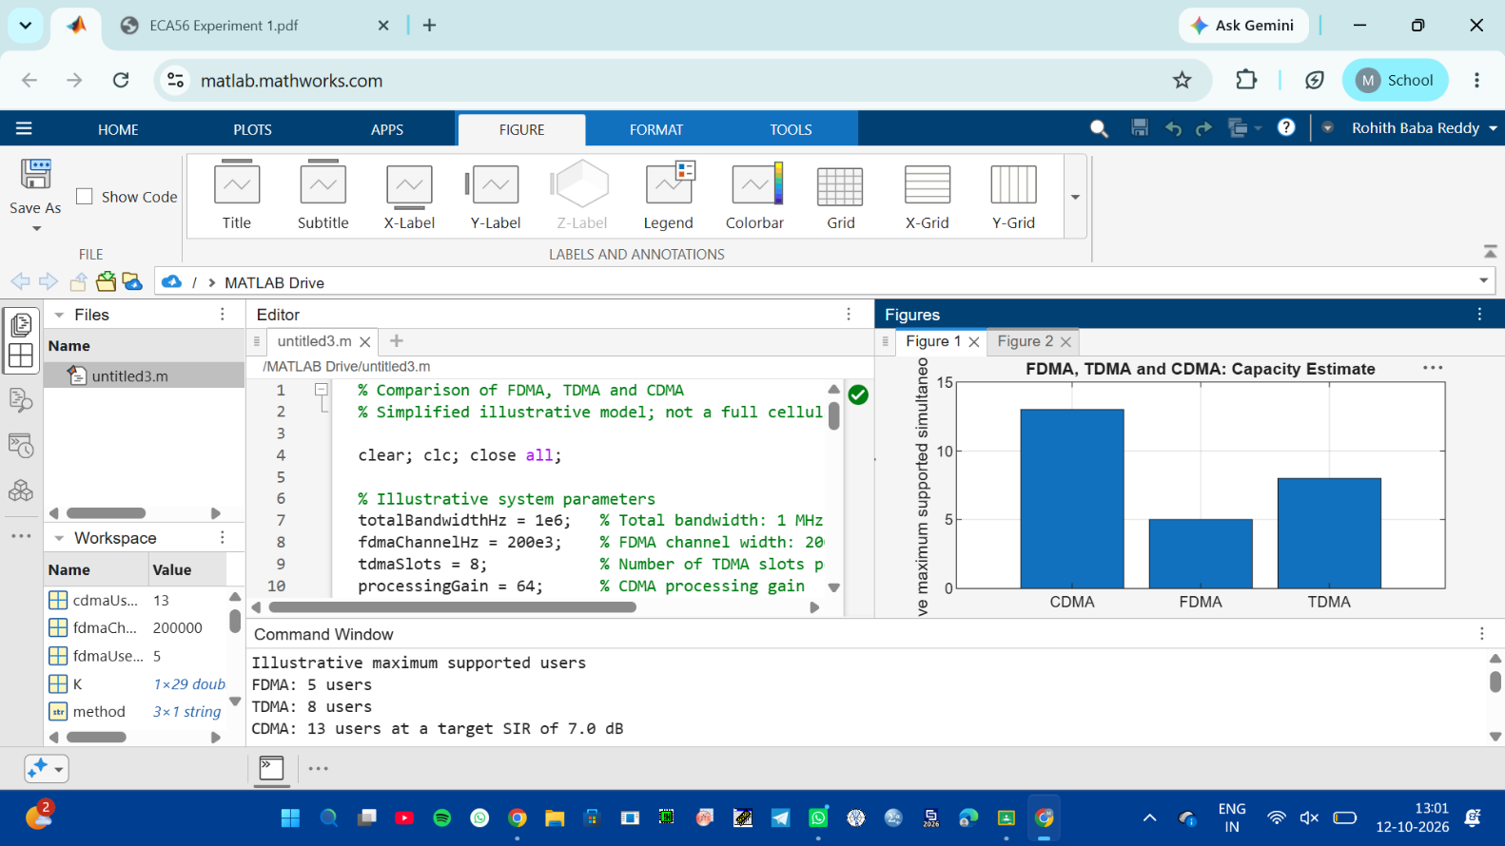

Objective 2: CDMA SIR analysis:
To analyze how the estimated CDMA signal-to-interference ratio changes as the number of simultaneous users increases.

Finding out the SIR for the technique with the highest number of users
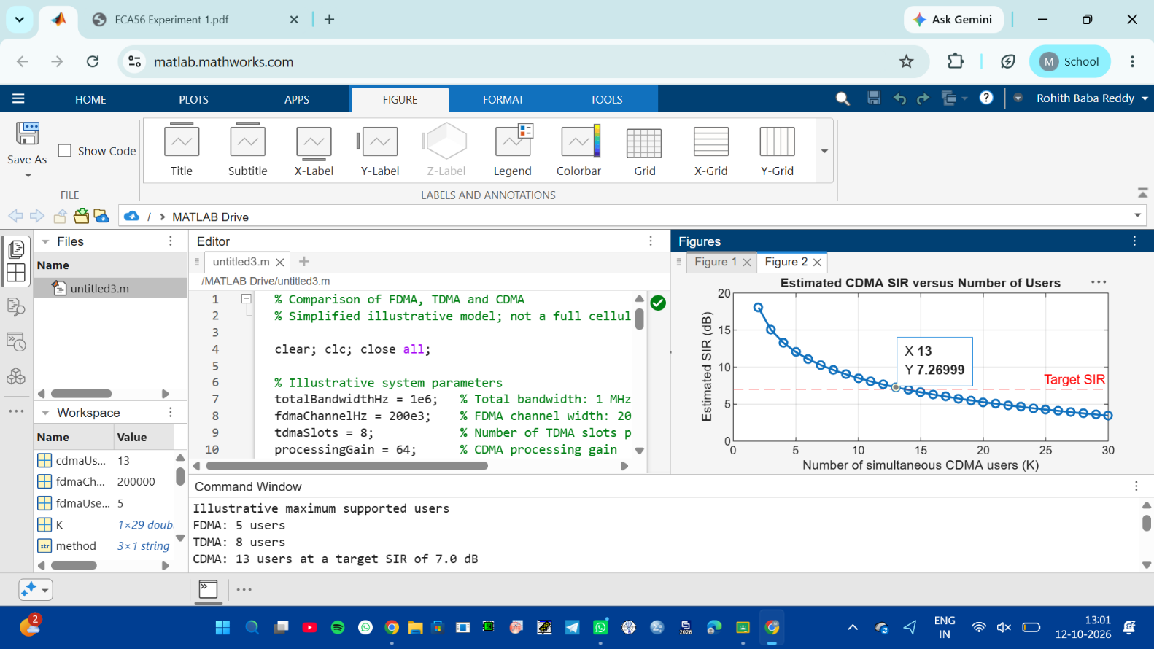

Objective 3: Mobile-generation comparison:
To relate representative multiple-access techniques to the evolution of mobile communication systems from 1G to 5G.

MATLAB Program:

generation = ["1G"; "2G"; "2G"; "3G"; "4G"; "5G"];
system = ["AMPS"; "GSM"; "IS-95"; "UMTS"; "LTE"; "5G NR"];
accessMethod = ["FDMA"; "TDMA"; "CDMA"; "WCDMA"; "OFDMA"; "OFDMA-based"];
keyIdea = ["Separate frequency channels"; ... "Separate time slots"; ...
"Code-based user separation"; ... "Wideband code-based access"; ... "Orthogonal frequency resources"; ... "Flexible OFDM-based radio access"];

evolutionTable = table(generation, system, accessMethod, keyIdea); disp(evolutionTable);

Result:

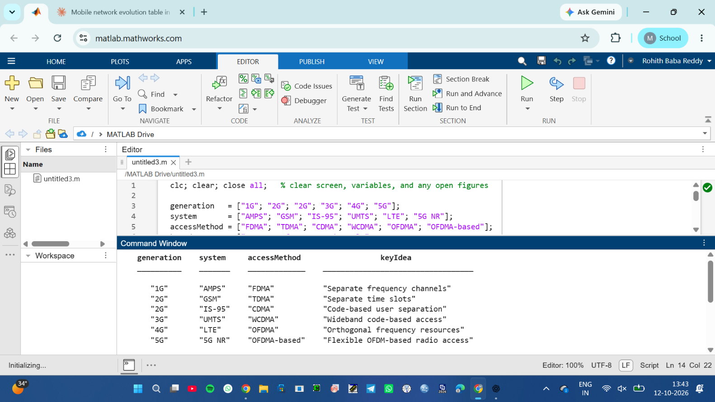

Objective 4: Resource-allocation diagrams:
To visualize how FDMA, TDMA and CDMA assign frequency, time and code resources to multiple users.

MATLAB Program:

Time-frequency resource-allocation diagrams
figure; tiledlayout(1,3);

% FDMA: users occupy different frequency channels nexttile;
hold on;
colors = lines(4); for u = 1:4
rectangle('Position',[0, u-1, 1, 0.8], ...
'FaceColor',colors(u,:), 'EdgeColor','k');
text(0.5, u-0.6, sprintf('User %d',u), ... 'HorizontalAlignment','center');
end
xlim([0 1]); ylim([0 4]); xlabel('Time'); ylabel('Frequency channel'); title('FDMA');
set(gca,'YTick',[]); hold off;

% TDMA: users occupy different time slots on one frequency channel nexttile;
hold on; for u = 1:4
rectangle('Position',[u-1, 0, 0.8, 1], ...
'FaceColor',colors(u,:), 'EdgeColor','k');
text(u-0.6, 0.5, sprintf('User %d',u), ... 'HorizontalAlignment','center');
end
xlim([0 4]); ylim([0 1]); xlabel('Time slot'); ylabel('Frequency channel'); title('TDMA'); set(gca,'YTick',[]);
hold off;

% CDMA: users share the same time and frequency band using different codes nexttile;
hold on; for u = 1:4
rectangle('Position',[0, 0, 1, 1], ...
'FaceColor',colors(u,:), 'FaceAlpha',0.22, ...
'EdgeColor',colors(u,:), 'LineWidth',1.5);
end
text(0.5, 0.62, 'Users 1-4 share', 'HorizontalAlignment','center'); text(0.5, 0.40, 'band; different codes', 'HorizontalAlignment','center'); xlim([0 1]); ylim([0 1]);
xlabel('Time'); ylabel('Frequency band'); title('CDMA'); set(gca,'YTick',[]);
hold off;

sgtitle('Conceptual Time-Frequency Resource Allocation');

Result:
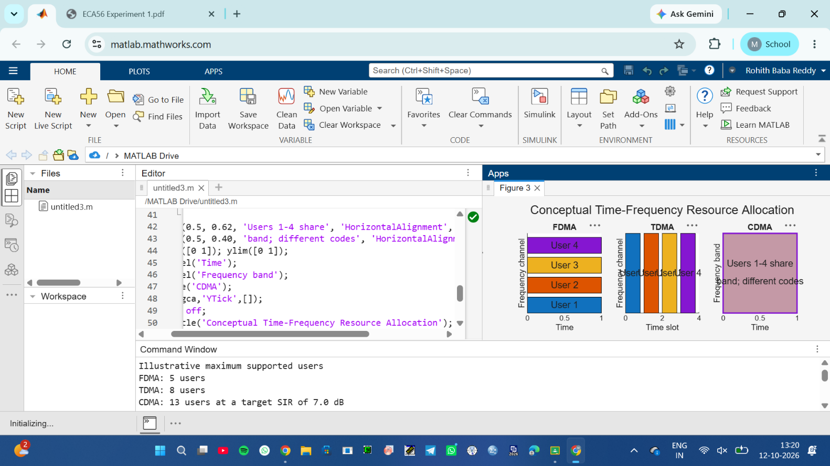

Conclusion
The four MATLAB programs demonstrate how FDMA, TDMA and CDMA allocate communication resources and how the assumed parameters affect their estimated user capacity. The CDMA analysis shows that estimated SIR decreases as more users share the same frequency band. The mobile-generation table and resource-allocation diagrams connect these techniques to the development of wireless communication systems.
These results are based on simplified assumptions. In particular, the model assumes ideal FDMA and TDMA separation and does not include real-world effects such as fading, power control, adjacent-channel interference or guard intervals. Therefore, the results illustrate the operating principles; they should not be treated as a universal performance ranking of the three methods.

Assessment Rubrics — Experiment 1: Simulation and Comparison of FDMA, TDMA and CDMA
Assessment criterion | Weight | 4 — Strong | 3 — Meets | 2 — Partial | 1 — Limited
Objective 1: |  | Correct | Outputs mostly | Some correct | Program fails,
Capacity |  | FDMA, | correct, with a | outputs, but | results mostly
estimation | 10 | TDMA and | minor error or | errors or | incorrect, or
and |  | CDMA | incomplete | omissions | assumptions not
comparison |  | estimates; clear | explanation. | remain. | understood.

Assessment criterion | Weight | 4 — Strong | 3 — Meets | 2 — Partial | 1 — Limited
 |  | table and chart; assumptions explained.
Objective 2: CDMA SIR  analysis | 10 | Correct SIR conversion, calculation and plot; target line shown; trend explained. | Plot and calculations mostly correct, with a minor error or incomplete interpretation. | Plot or calculations contain errors; trend only partly explained. | Program or plot missing/incorrect, or trend misinterpreted.
Objective 3: Mobile-generation comparison | 10 | Correctly links representative generations, systems and access methods; distinctions explained. | Mostly accurate, with a minor omission or imprecise description. | Several entries incomplete or unclear. | Table missing or contains major inaccuracies.
Objective 4: Resource-allocation diagrams | 10 | Clearly and correctly shows FDMA  frequency separation, TDMA time slots and CDMA code-based sharing. | Diagrams understandable, with minor labeling or presentation issues. | One or more allocation concepts unclear or incorrectly shown. | Diagrams missing or substantially incorrect.
Parameter study and | 15 | Changes relevant  parameters, | Provides rerun results and  comparison, but | Makes limited  changes or | No meaningful parameter study or

Assessment criterion | Weight | 4 — Strong | 3 — Meets | 2 — Partial | 1 — Limited
recorded results |  | reruns applicable programs, records outputs and explains effects. | one change or explanation is incomplete. | records results without clear comparison. | usable results record.
Analysis and interpretation | 20 | Answers questions accurately, uses results as evidence and distinguishes model behavior from real-system behavior. | Most answers sound and refer to results, with some gaps in explanation. | Answers partly correct but mainly describe outputs without explaining them. | Analysis missing, unsupported or substantially incorrect.
Engineering judgment and conclusion | 15 | Gives a clear conclusion, identifies assumptions and limitations, and avoids unsupported performance rankings. | Conclusion is reasonable but omits a relevant assumption, limitation or implication. | Conclusion mostly repeats results, with little discussion of limitations. | Conclusion missing or draws unsupported conclusions.
Report organization and evidence | 5 | Includes code, tables, required figures, parameter | Required evidence present with minor organization or  labeling issues. | Some evidence missing or difficult to  follow. | Report substantially incomplete or unclear.
Assessment criterion | Weight | 4 — Strong | 3 — Meets | 2 — Partial | 1 — Limited
 |  | values and clear captions.
Individual explanation / viva | 5 | Clearly explains their own work, formulas and results. | Explains most aspects, with minor gaps. | Gives partial explanations but struggles to connect code and results. | Cannot explain key parts of the submitted work.
Total | 100

